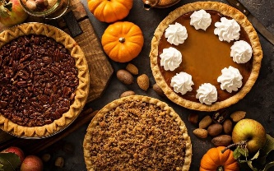  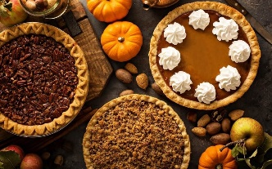 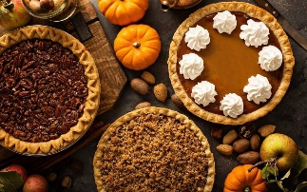 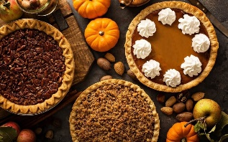

\

**Tabora Farm and Orchard**

**Pie Order Form 2024**

1104 Upper Stump Rd, Chalfont PA 18914

**Traditional Apple** – Hand mixed varieties of apples from our own farm, delicately balanced with spice.

**Apple Raspberry** – Sweet apples mixed with tart raspberries balances the pie very well.

**Banana Cream** – Double boiled custard mixed with fresh bananas, topped with homemade whipped cream. (Requires refrigeration) **$16.59**

**Blueberry** – Local flash frozen blueberries offer the taste of summer any time of the year.

**Cherry** - Classic cherry pie made with Montmorency sour cherries.

**Coconut Cream** – Toasted coconut with custard and fresh whipped cream. (Requires refrigeration) **$16.59**

**Coconut Custard** – Homemade custard combined with sweet coconut and then baked to a light golden brown. (Requires refrigeration) **$16.59**

**French Apple Streusel--** Traditional apple pie with a cinnamon sugar crumb, topped with a fondant drizzle. Delicious! **$16.59**

**Key Lime** – A sweet graham cracker crust merged with a tart lime filling, all homemade. (Requires refrigeration) **$16.59**

**Lemon Meringue** – Nothing from a can! From scratch lemon curd topped with from scratch meringue made in small batches guarantees delight! **$16.59**

**Mincemeat** – An old fashion goodie that actually has meat mixed with raisins, apples in a sweet sauce. **$16.59**

**Mixed Berry** –Our family’s favorite! A perfect combination of strawberries, cherries, raspberries, blackberries, and blueberries.

**Pecan** – Our famous southern recipe makes our pie the official award winner! **$16.59**

**Pumpkin** – Silky smooth pumpkin perfectly balanced with nutmeg, cinnamon and our other secret spices.

**Strawberry Rhubarb** – Sweet Strawberries combined with tart rhubarb in this authentic strawberry rhubarb pie.

**Sweet Potato –** Soft and naturally sweet a great traditional pie for those looking for something other than pumpkin. $**16.59**

**Flip over for the order form! Thank you for your interest in Tabora!**

Most pies are $**14.99**. All fruit pies available in crumb topping

Call for Sugar free pie option available in the fruit pies! **$16.59** Call and place this order.

All pies are made without additives and preservatives. Please Consume Within 24-48 Hours or Freeze

……………………………………………………………………………………………………………………………………………………………………………………………………

Name________________________________

Phone Number ________________________________

Date of Pickup____________________ Approximate Time________

Pie Name Quantity Crumb Price

(Example)Traditional Apple 2 no $29.98

1.__________________________________________ _________ ______ ________

2.__________________________________________ _________ ______ ________

3.__________________________________________ _________ ______ ________

4.__________________________________________ _________ ______ ________

5.__________________________________________ _________ ______ ________

**TOTAL** ________

Tabora Farm and Orchard

1104 Upper Stump Rd

Chalfont PA 18914 215-249-3016

**Happy Thanksgiving from all of us at Tabora Farms!!**